

Policy Statement
Anti Bullying

Date: Autumn 2024
Review Date: Autumn 2026

Formally adopted by the Governing Body of:

Bodringallt Primary School - Autumn 2024

Signed (Chair of Governing Body ) - Mrs L Llewellyn

Signed Head teacher - Mr S Howells

Anti-Bullying

We follow the RCT Anti-Bullying Policy and Guidance for Schools most recent documentation.

Definition of bullying

“Deliberately hurtful (including aggression), repeated often over a period of time (whilst recognising that even a one off incident can leave a pupil traumatised and nervous of future recurrence). Difficult for victims to defend themselves against.”

“Bullying is aggressive or insulting behaviour by an individual or group, often repeated over a period of time that intentionally hurts or harms.”

Strategies for the school

Bullying is dealt with as a whole-school issue. This includes: awareness-raising, actively involving pupils in drawing up definitions and seeking solutions, curricular work and work in the school environment and acceptable and unacceptable behaviours.

Bullying and its effects may be exemplified and reinforced through many areas of the curriculum:
- PSE / Health + Wellbeing
- Creative writing in English lessons
- Drama
- History
- Religious Education

A good deal of bullying takes place outside the school gates, and on journeys to and from school. Perpetrators of the bullying may be pupils of the school, pupils of other schools, or people not at school at all. We encourage pupils not to suffer in silence. Where a pupil tells of bullying off the school premises, a range of steps could be taken:
- talking to the local police about problems on local streets (if necessary seek a police presence at trouble spots: contact school liaison officers)
- considering involving parents or members of the local community
- talking to the head of another school whose pupils are bullying off the premises
- mapping safe routes to school, and tell pupils about them
- talking to pupils about how to avoid or handle bullying outside the school premises

The Equality Act 2010 requires us to have a strategic equality plan. We ensure that the equality objectives suit the needs of the school and support the school successfully in promoting equality and diversity and bullying on the grounds of the protected characteristics is reduced.

Procedures including reporting

- talk to bullying victim
- talk to alleged bully
- design coping strategies for the victim to avoid the situation
- alert teachers as to the issue
- allow the victim and bully to meet and discuss issues leading to conflict resolution
- sanctions on bully (contact home; internal exclusion; exclusion)

Every case is different and will require different solutions; however the policy should be upheld so that any victim of bullying can see that the issue is dealt with and resolved.

Ability to identify behaviour as bullying

Verbal Bullying:

Calling names, teasing, taunting, threatening, insulting and making offensive remarks [including sexist homophobic and racist comments] are all included in this type of bullying.

Physical Bullying:

Pushing, punching, kicking, spitting, fighting, stealing and sexual assault can result in physical bullying.

Social Bullying:

Intimidation, dirty looks, rumour spreading, breaking friends, isolating individuals, publicly writing, or displaying literature about a person.

Online Bullying

Online bullying is an aggressive, intentional act carried out by a group or individual using electronic forms of contact repeatedly over time against a victim who cannot easily defend themselves. Online bullying is an increasing and more recent problem and is particularly difficult to address. The potential audience for online bullying is huge. Several types of online bullying have been identified:

Text message bullying involves sending unwanted texts that threaten or are hurtful. This is one of the most common forms of online bullying and is now a criminal offence.
E-mail bullying involves sending threatening messages often under a false name or using someone else’s name on which to pin the blame.
Social media and on line bullying involves sending menacing or upsetting responses to children when they are in a web-based chat room.
Bullying via websites includes the use of defamatory web logs [blogs], personal websites and online personal polling sites.

There has also been a significant increase in social networking sites for young people such as Snapchat, Facebook, Ask.FM, KIK and Twitter which provide further opportunities for online bullying.

Damage to Property:

Intentionally damaging other people’s property; graffiti.

Bullying incidents on the basis of protected characteristics as identified in Equalities Act (2010)

Disability / Special Needs / Medical condition

Real or perceived disability, special need, gifted or talented or health conditions or association with someone in those categories (related derogatory language for example: retard / spaz / geek / nerd) or association with someone with a disability / special need

Gender Identity (Transphobic Bullying)
Transgender, perceived to be transgender, someone whose gender or gender identity is seen as being different to typical gender norms, or someone who has a transgender family member. Language/stereotyped perceptions of gender (sissy, butch, she/ he, gender bender, tranny)

Race / Ethnicity
Ethnic origin, skin colour, national origin, culture, language, real or perceived or because of their association with someone of a particular ethnicity, culture etc (racism)

Religion / Belief
Beliefs, faith, mistaken identity, lack of faith (Islamophobia and anti-Semitism for example). It may also be because of a perception or assumption about religion or belief (which may or may not be accurate), or because of their association with someone of a particular religion or belief

Sexual Orientation
Related to sexual orientation or perceived orientation of target or target’s family / friends and/or homophobic / biphobic abuse and language used. This incorporates:
Homophobic bullying
Homophobic bullying occurs when bullying is motivated by a prejudice against lesbian, gay or bisexual people. This can affect:
- Young people who identify as lesbian, gay or bisexual (LGB).
- Young people who are perceived by others to be lesbian, gay or bisexual.
- Young people who are different in some way – they may not act like the other boys or girls.
- Young people who have gay, lesbian or bisexual friends, or family, or parents/carers are gay,
lesbian or bisexual.
- Teachers, who may or may not be lesbian, gay or bisexual.

Biphobic bullying
Bisexual people may experience homophobic bullying but they are also likely to experience biphobia, that is, prejudice which is specifically related to their bisexual identity. Biphobia often takes the form of stereotypes: for example, that bisexual people are ‘greedy’, ‘promiscuous’ or ‘confused’. Bisexual people can experience biphobic prejudice from both heterosexual people and lesbian and gay people".

Sex (Gender)

Based on sexist attitudes that when expressed demean, intimidate or harm another person because of their sex or gender. Language such as bitch, slag etc (sexism)

Strategies for pupils
Pupils are encouraged to report bullying, including important indirect ways, and are to be given information about support for both victims and perpetrators. For example, evidence of peer support, bully boxes, web reporting etc.

If all efforts fail to help pupils stop bullying, we will need to take tougher action to deal with persistent and violent bullying. We will need to make sure that the whole school community knows what sanctions will be used. They will be fairly and consistently applied. Pupils are made aware that their behaviour is related to an outcome and has consequences for themselves and others. Possible disciplinary processes include:
- Withdrawal to a “Quiet Area”. Removing the pupil from the class or situation, not so much as a punishment, but rather as a time when they can think about their behaviour and often a solution
- Denial of privileges, with the opportunity to redeem one’s self
- Individual pupil management plan
- Restorative Approaches
- Parental involvement
- Counselling
- Removal of bully away from the victim (e.g. into another class)

If all steps fail it may be necessary to exclude the pupil for a fixed period or, particularly where serious violence is involved, the head teacher has the option of permanently excluding the pupil. In these cases, it may be necessary to inform the police. Permanent exclusion however, should not be a standard course of action and each case should be considered separately.

This policy builds mutual understanding and respect in children and young people. Promoting tolerance helps to prevent children and young people becoming perpetrators of Hate Crime in adult life.

A Hate Crime is defined as a criminal offence.......
which is perceived by the victim or any other person to be motivated by a hostility or prejudice, based on a person’s actual or perceived disability, race, religion and belief, sexual orientation and transgender.

Put simply, if someone targets you because of who you are or who they think you are along the lines of disability, race, religion and belief, sexual orientation and transgender then this is a Hate Crime or a Hate Incident. Hate crimes are serious criminal offences that have a higher level of sentencing. Where someone is targeted because of their age or life style choice, (for example Goths), then this is also recorded as a Hate Crime or a Hate Incident, but without the enhanced level of sentencing, although support services would still be available.

Hate Crime or Hate Incidents may include –
- Verbal abuse
- Offensive graffiti
- Threatening behaviour
- Damage to property
- Assault
- Online bullying
- Abusive texts, emails or phone calls
- Taking money, valuables or your possessions

Most Hate Incidents within schools are most effectively managed via the Anti-Bullying Policy and with a restorative practice approach. Serious Hate Crimes may be reported as outlined below –

Hate Crimes or Hate Incidents may be reported to the Police on 101 or 999 in an emergency. All victims of Hate Crime are appointed a specially trained Hate Crime Support Officer.

Hate Crimes or Hate Incidents can also be reported to the Official National Hate Crime Report and Support Centre for Wales. This is a confidential reporting and support service run by Victim Support.

0300 30 31 982 (free 24/7)
www.reporthate.victimsupport.org.uk

Victim Support has been funded by the Welsh Government to increase the reporting of hate crimes and hate incidents across Wales and to offer support to victims of these offences. Working with other organisations such as the Police, Victim Support can be pro-actively preventing further hate offences through local and national targeted interventions. Hate incidents and hate crimes are under-reported. We need to understand the problem so that the right decisions can be made to stop people from becoming the next victim.

- People in immediate danger should call the Police directly by dialling 999, or 101 for non-emergencies.
- Victim Support can be contacted directly on (Free) 0300 30 31 982 (24/7). Calls are treated confidentially and there is the option to remain anonymous.
- Reporting online is available at www.reporthate.victimsupport.org.uk

‘Mate Crime’ is when someone has been targeted by so-called ‘friends’, usually because of a learning disability. Victims are often exploited for their money, accommodation or possessions.

Strategies for parents

Parental support is key to success or failure in anti-bullying initiatives. Though not always apparent, parental approval is important to children and young people of all ages, and we haves have learned to build on this. The majority of parents support our anti-bullying measures and are keen to participate. Our useful approaches include:

- Regular communication
- Providing information about the nature and effects of bullying, by means of leaflets
- Raising the profile of online sources of information and support
- Advising parents of possible consequences of their children bringing valuable items to school

Parents can also be kept informed through:
- Leaflets and newsletters home
- Open days
- Anti-bullying weeks
- The school prospectus
- The school website

Talking to teachers about bullying:
- Try to stay calm
- Be as specific as possible about what your child says has happened
- Make a note of what action the school intends to take
- Ask if there is anything you can do to help your child at school
- Stay in touch with the school

If your concerns are not being addressed:
- Check the school anti-bullying policy to see if agreed procedures are being followed
- Make an appointment to meet the head teacher
- If this does not help, follow the school’s complaints procedure

Training

We provide staff and governors with training about combating bullying with the advice and support from the LA and how to help pupils develop resilience to bullying. Staff are encourage to read the Welsh Government Guidance ‘Respecting Others’ to raise awareness of issues
[http://wales.gov.uk/topics/educationandskills/publications/circulars/antibullying/?lang=en]

Schools have a legal duty to ensure bullying is dealt with. Under the Education and Inspections Act 2006, head teachers, with the advice and guidance of governors and the assistance of school staff, must identify and implement measures to promote good behaviour, respect for others, and self-discipline among pupils, and to prevent all forms of bullying. The Equality Act 2010 specifically relates to those with protected characteristics.

The increase in online bullying has created new forms of bullying. Staff and governor training in e-learning and technology provides a good opportunity to develop practice creatively and to support children and young people in their safe and responsible use.

RESPONDING TO INCIDENTS OF BULLYING

School based recording and monitoring of incidents

When incidents of bullying occur, it is recommended that detailed records are maintained and data analysed to identify trends and corrective action is required. Issues and concerns should warrant further investigation and prompt action, and where appropriate, prioritisation with strategic plans. See Appendix 2 of guidance.

Local Authority recording of school-based incidents

All school-based incidents should be reported to the local authority termly. See Appendix 3 of guidance.

PROCEDURES FOR DEALING WITH INCIDENTS OF BULLYING

School based decision making
A suggested process map is provided overleaf to inform school-based decision making when responding to incidents of bullying. This is a suggested response. Every bullying incident is different and therefore whilst the diagram below may prove helpful, it is likely to need adapting to suit individual settings’ circumstances

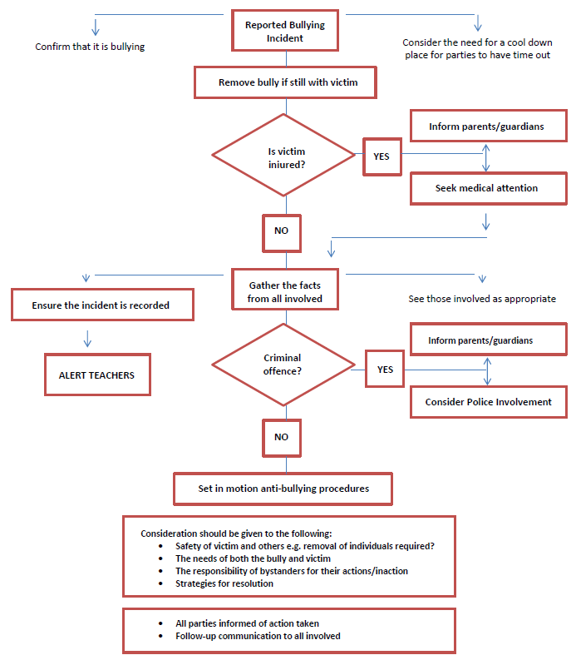

Proactive whole school initiatives that we use:
- Circle Time
- Rainbow
- PCSOa and Police Liaison
- Spectrum
- Buddying Schemes
- Restorative Approaches
- ‘Rights Respecting School’ Award (RRSA)
- Take part in Anti-bullying week every year in November
- We use Part 2 of RCT’s Anti-bullying Guidance to tackle bullying in the school.

Review

The governing body will review this policy annually. The governors may, however review this policy earlier if they receive recommendations on how it may be improved or if there is a change in regulations.

